# Topic_07 Extreme Tone

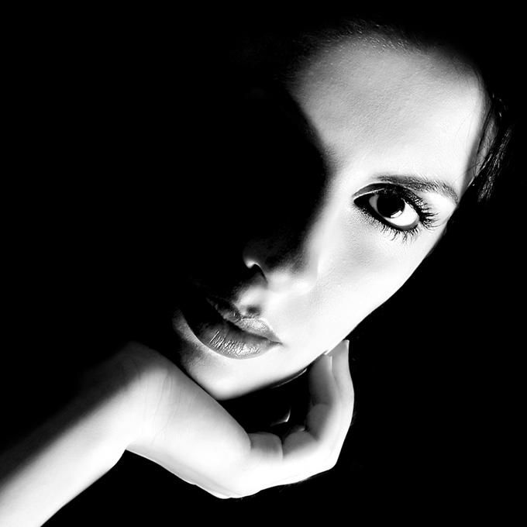The Visual Element of Tone defines the lightness or darkness of a colour. The tonal values of an artwork can be adjusted to alter its expressive character.

Tone can be used:

* to create a contrast of light and dark.
* to create the illusion of form.
* to create a dramatic or tranquil atmosphere.
* to create a sense of depth and distance.
* to create a rhythm or pattern within a composition.

## [Chiaroscuro](https://www.google.com/search?q=chiaroscuro&rlz=1C1GCEA_enAU940AU941&oq=Chiaroscuro&aqs=chrome.0.0i67i131i433j0i67l2j0i67i131i433j0i131i433j0l3j46j0.460j0j1&sourceid=chrome&ie=UTF-8&safe=active&ssui=on)

Extreme light and dark contrasts within Chiaroscuro a work of art. The word "chiaro" means light and "scuro" means dark. An extreme light source illuminates the rest of the composition and this light source becomes the emphasis in the composition.  
 Note: The term Chiaroscruo should only be used to discuss works of art that have this extreme light and dark. It shouldnt be used to describe just small areas in a work of art, but rather the entire composition.

## A picture containing wall, indoor Description automatically generatedActivity _01 Still life in Chiaroscuro

Draw two different compositions of still life in extreme tone - use photo for composition reference only, invent the lighting in Chiaroscuro style

Activity_02 White Calla Lily

Draw two or three different interpretation of flower in extreme tone