# Lesson _ 1 Basic shapes in perspective.

Exercise 01  
let’s work a bit more on consolidating our familiarity with the four basic shapes: cones, spheres, boxes and cylinders.  Start by sketching the image below.

Don’t worry about making the shading smooth; the most important thing is to work on object shape, correct perspective and composition keep it simple line drawing.

You can either draw the shapes using the grid, or without it. (I’d recommend the grid because it makes the negative spaces easier to see.)

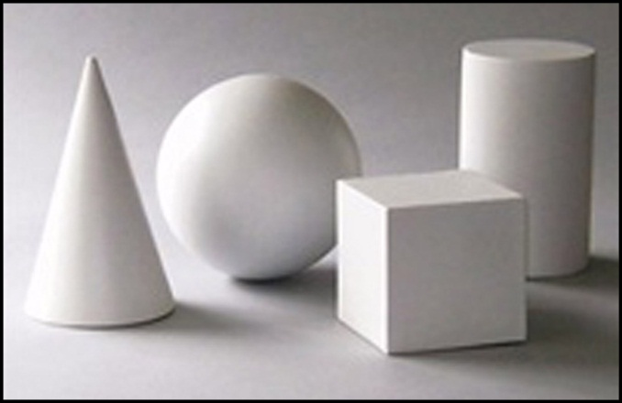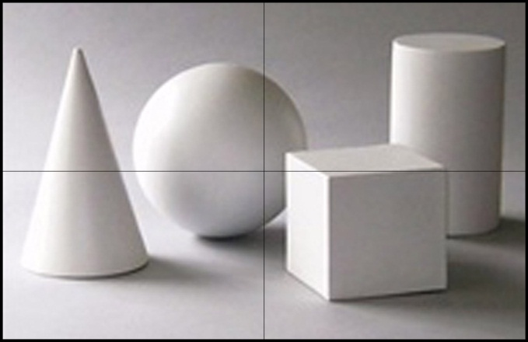

## Exercise 02

Try drawing some more complex objects, try to break complex object into range of simple shapes (cylinders, cones, boxes and/or spheres). See the examples on the left, use photos of stone garden urns from resource folder Exercise_02.jpg and Exercise_02b.jpg.

Draw the shapes using the grid concentrate on proportions and construction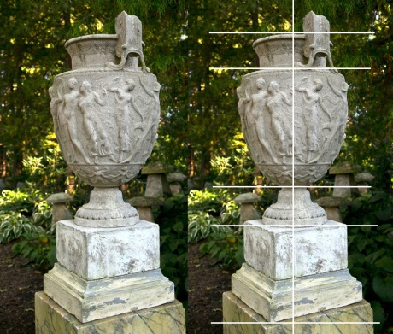

## Exercise 03

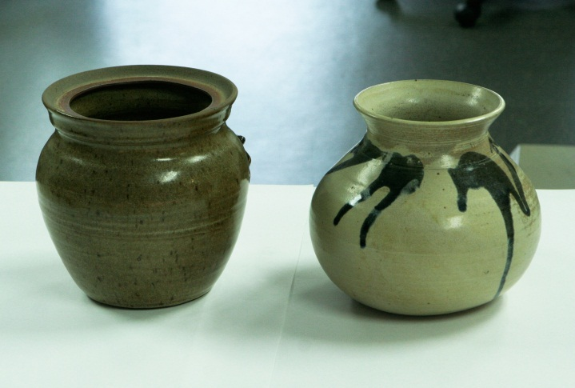Looking at correct proportions and character of the object,

Look at these two pots next to each over. They are similar although they have slightly different proportions and character, tray to spot that difference and analyse it

Draw the objects try to accentuate objects individual character and stress difference between pots,

## Exercise 04 Intuitive perspective

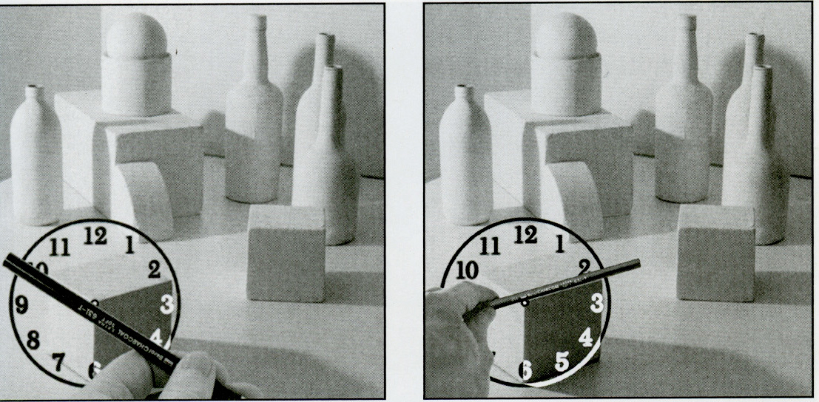

On this illustration student using “clock-angle” method to eyeball perspective of the cube.   
Try to draw this installation (photo below) notice that all objects in this still-life have different perspective angles, use intuitive perspective or clock-angle method to draw perspective correctly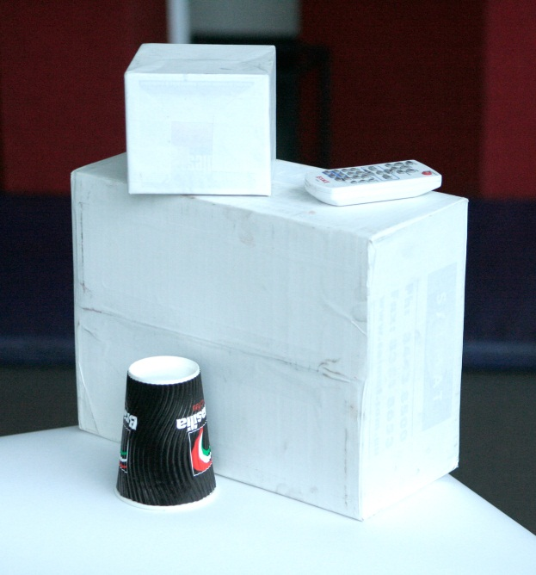

## Home work:

Continue to exercise drawing basic shapes in perspective. If you have time, try drawing a still life of some simple objects (cylinders, cones, boxes and/or spheres).  For example, you might set out, on a table top, an orange, apple, box of cereal, and can of jam.