# Topic_03 Gesture and Flow https://learn.tafesa.edu.au/course/view.php?id=2784

## gesture2.jpgClass Discussion So what exactly is gesture anyway?

Gesture, rhythm, motion, action, flow – these are all words that are used interchangeably and they basically mean the same thing.

They all refer to the movement between things. It’s not the contour, or the form, or the tone. It’s the movement that connects the contours, the forms and the tones.

1. Watch video “How to Draw Gesture”  
   <https://www.proko.com/how-to-draw-gesture/#.YBjrm-gza70>
2. Watch the video “Improving Line Quality and Rhythm - FORCE Series Part 1”  
   <https://www.youtube.com/watch?v=IyuCq6VWVeA>

## Activity _01: Drawing trees

Follow lecturer presentation and draw tree trunk using organic flow lines only

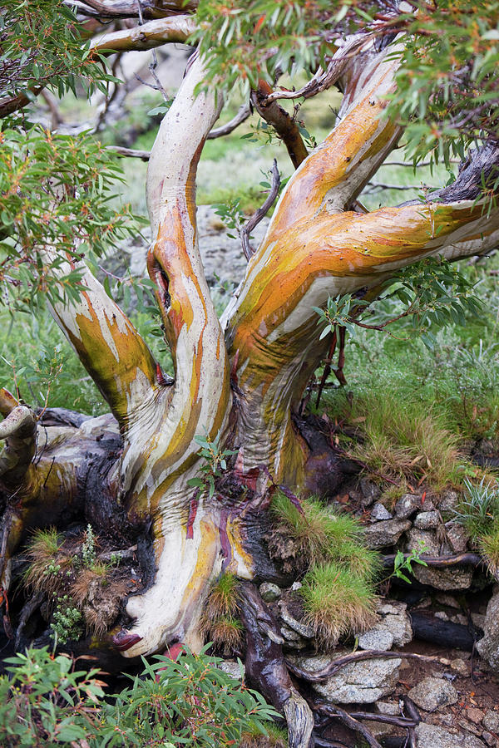

Activity_02 Drawing trees brunches flow

This time try to capture rithm of the tree brunches use brunhes silhuette and positive and negative space, folow rithms:

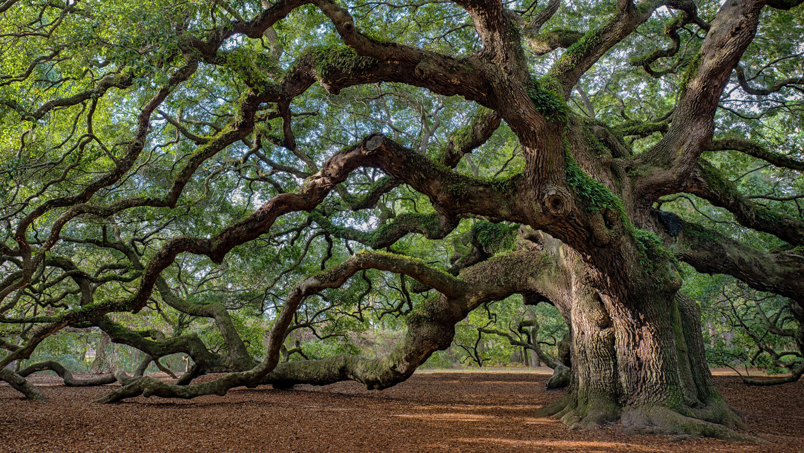

Activity_03 Drawing human character using gesture lines

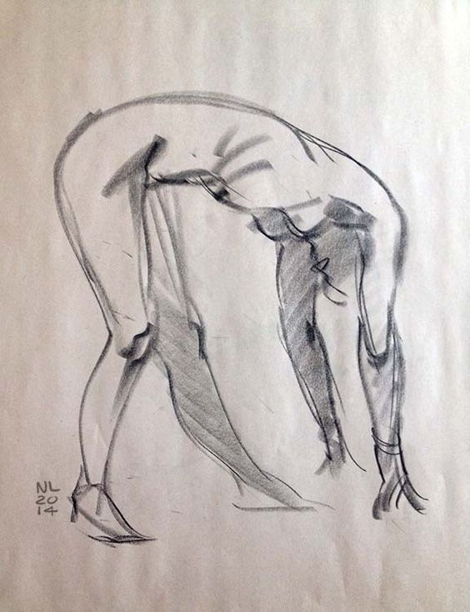

Draw gesture “energy lines” only don’t worry about proportions and structure:

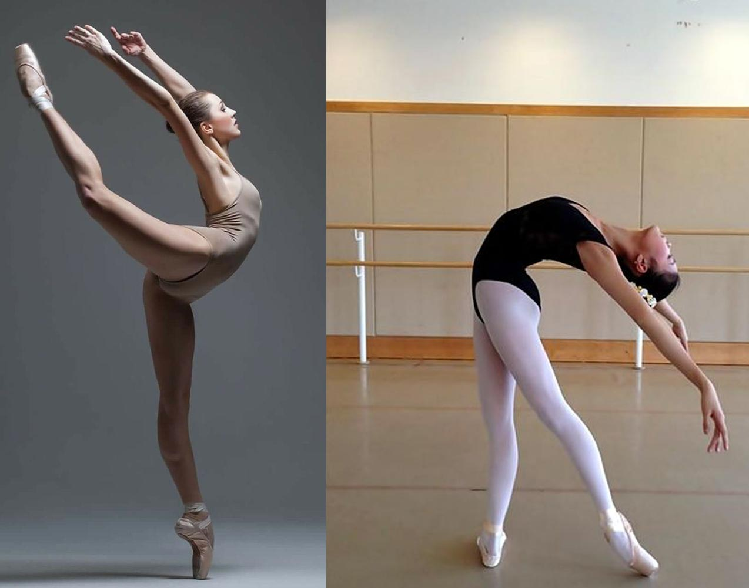

Activity_04 Patterns and Rhythms

Draw organic patterns of pineapple concentrate on structure and rhythm:

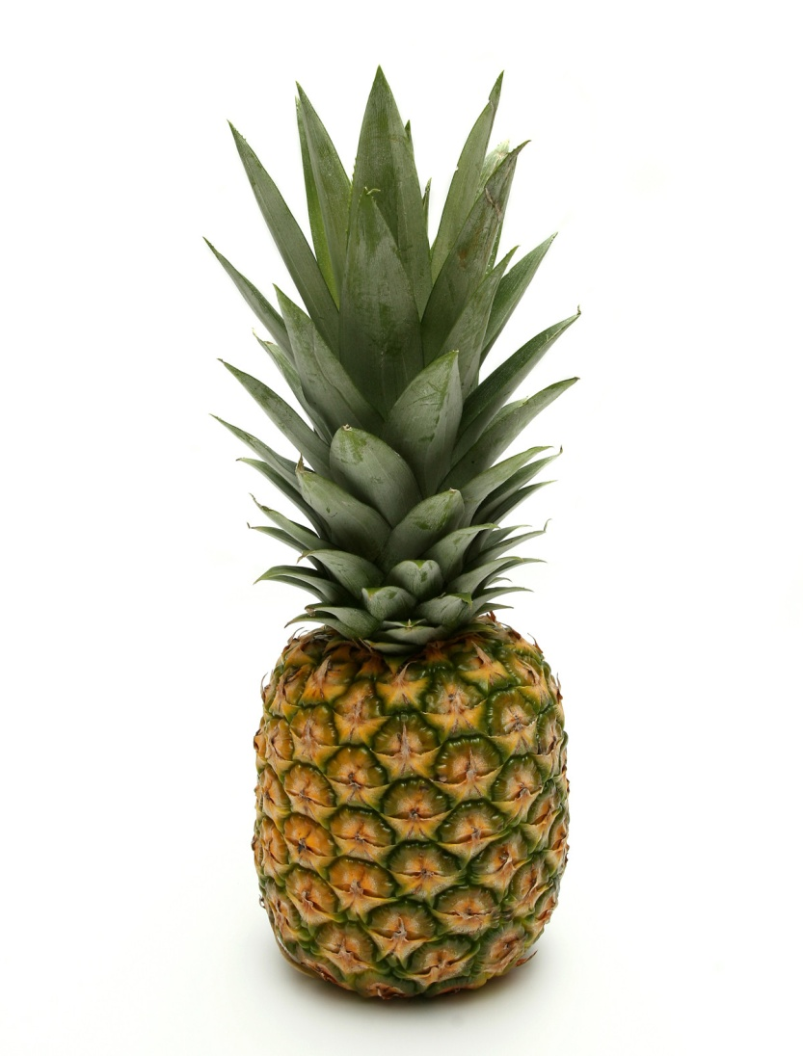

Activity_05 Rhythms and Positive and Negative Space

Draw buch of Garlic flowers consentrate on lihe floor and negative space between plants

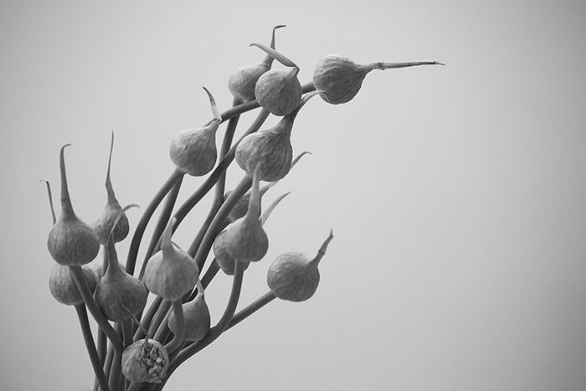

Activity_06 Study of Will Weston anatomy – perfect balance between gesture and structure

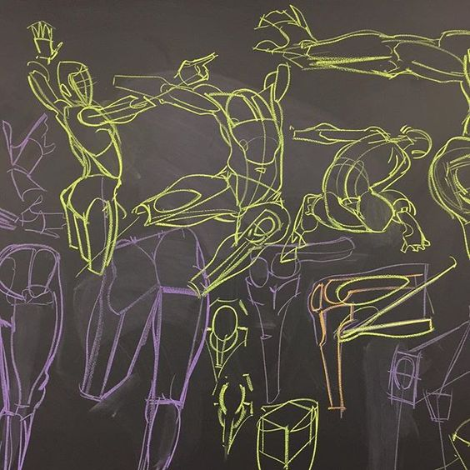Copy couple of Will Weston’s black bord body shematic, try to capture gesture and simple structure: