# Topic_04 Perspective https://learn.tafesa.edu.au/course/view.php?id=2784

## In this lesson we review the principles of perspective. Review the terms vanishing point and horizon line, overlapping and twist

**The Illusion of Depth – Perspective, Details and Overlapping Forms**

1. Watch video “The Illusion of Depth - Perspective, Details and Overlapping Forms”  
   <https://www.youtube.com/watch?v=LIuNehjFmUU&t=1s>

## Activity _01: One-point perspective

A) Follow lecturer presentation and draw (construct) one-point perspective from reference image:

B) Use Adelaide reference below to draw schematic of One Point Perspective

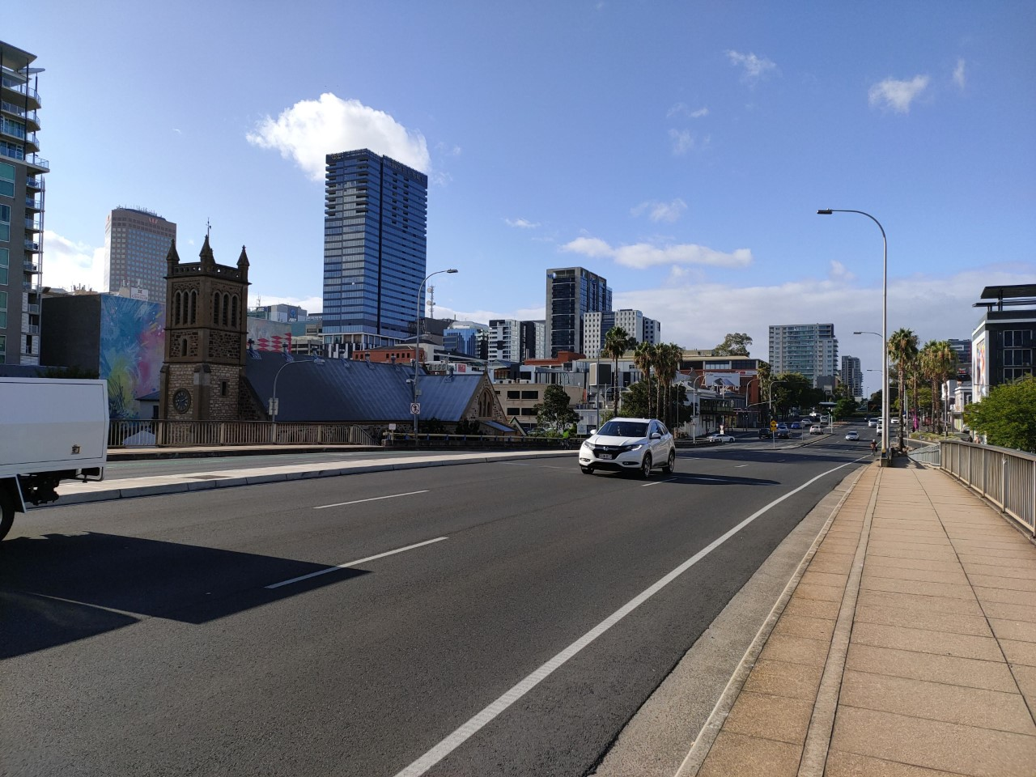

Activity_02 Drawing perspective in intuitive way

Draw cabins in pictures below without constructions line and vaniting points, eye-ball the angles and convergence of lines:

Activity_03 Overlapping

Draw Tuscany lanscape (Italy) curved road with cypress, near Pienza touristic village, Italy, use ovelapping shapes to convey illusionof depth

Activity_04 “Twists & Curls”

Draw organic shapes from reference. A twisting or curling leaf (or petal) typically shows portions of both its upper and lower surfaces in one view.

Activity_05 Leaf in Perspective

Draw fig leafs from referebnce image combine twist and perspective:

