# Topic_06 Stylising and Simplifying

## 

## Simplifying the Subject, looking at the subject using different approach

Real Life subjects that artist or designer have to draw have lots and lots of "shapes".

Copying exactly what we see is a natural thing for an artist to do.  But often, this leads to a simple duplication of reality. But there is more to drawing that just copying.  And one of the many things that can help you be more creative, more of an artist than a simple copyist, is to begin to see how you can simplify your subject matter into an arrangement of strong shapes.

Grouping and simplifying should be your aim,… ideally.

A drawing should be made up of large, medium, and small shapes - with the emphasis on the large, main shapes FIRST and foremost.  If you spend too much time on the fiddly, tiny shapes, or if you begin with those small shapes, you will lose sight of the large, main shapes.  This is the key to learning how to simplify and how to begin a drawing.

BEGIN WITH THE BIG SHAPES.

## Activity _01 Rhino

Draw series of quick sketches trying to progressively simplify and stylise rhino step by step.

Try to reduce amount of shapes and details from sketch to sketch like in the example above (Picasso study of bull)

Activity_02 Rabbit

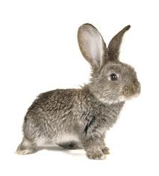 Draw series of quick pencil sketches truing to simplify and stylise rabbit

Concentrate on line and volume.

Start with linear drawing sketch, than introduce volume, finish with silhouette sketch try to use variety of drawing techniques

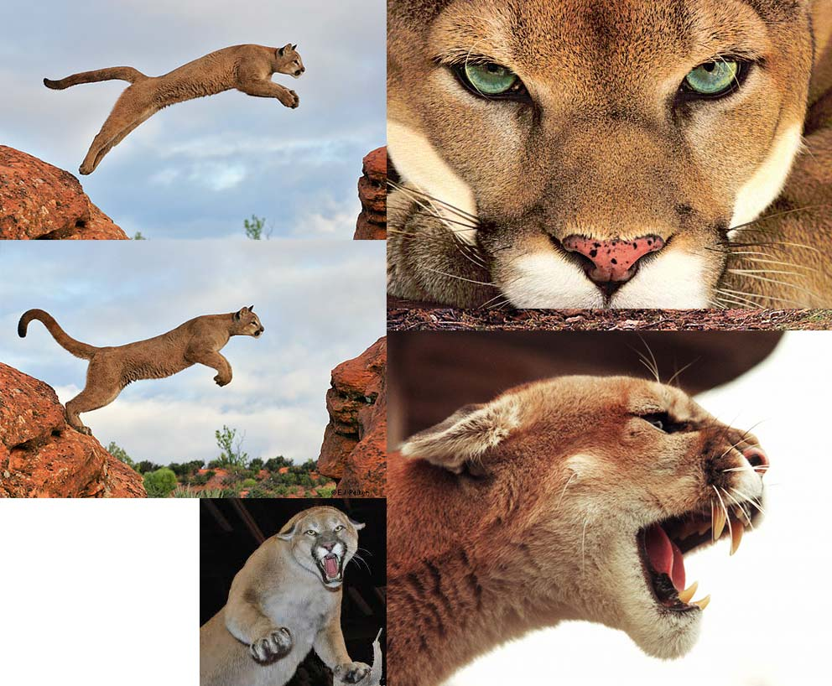Activity_03 Cougar

Sketch 3 ideas for logo featuring “Cougar” theme

* One more realistic looking
* One heavily simplified using basic shapes
* One abstract icon

Activity_04 Game Prop

Sketch 3 ideas game prop “Stylized Hammer” using reference image as an inspiration:

