# Topic_05 Textures and Patterns https://learn.tafesa.edu.au/course/view.php?id=2784

## In this lesson we look at surface rendering. How to draw Textures and Surface Patterns. Texture is one of the seven elements of art and design. In traditional Drawing – texture is subordinate to all the other elements of art. Simply put, texture is both the least important and the most challenging. However in Game Art and CGI industry creating realistic texture - materials is one of the most important and sought after skills.

## 

## Drawing texture boils down to observing the surface and analysing unique surface quality and patterns using mark-making and edge quality (hardness and softness of a contour). If you make the same type of marks with your drawing tools you will get the same texture over and over. Each unique texture requires a unique mark and approach.

## Follow these simple rules when drawing textures:

## Form dominates texture.

## Observe surface texture; each texture requires a unique mark and drawing technique.

## Flow and patterns of surface details creates texture

## Value creates texture.

## 

## Watch “Material Studies - Digital Painting in Adobe Photoshop”:

## <https://www.youtube.com/watch?v=08SBTqHbhjM>

## Add set of “Mr--Jack's brushes” Photoshop Brushes used in the video to your brushes window in Photoshop

## <https://www.deviantart.com/mr--jack/art/TheBrush-es-118144957>

## Activity _01: Draw pine wood plank

Follow lecturer presentation and draw pine wood plank from reference.  
Plank form first then pine wood grain patterns.

Activity_02 Draw apple with skin texture

Follow lecturer presentation and draw apple from reference.  
Apple form first, then skin patterns.

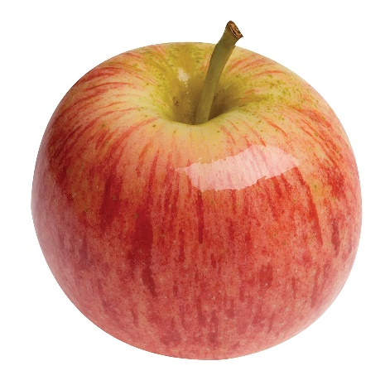

Activity_03 Pine bark pattern

Follow lecturer presentation and draw pine bark reference.  
Bark structure first, then texture values.

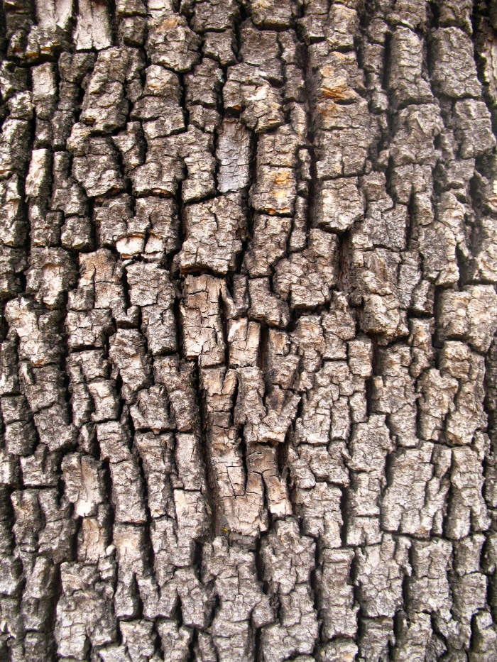

Activity_04 Wood Roof Tiles

Follow lecturer presentation and draw wood roof tiles.  
tiles shape first, then wood texture values.

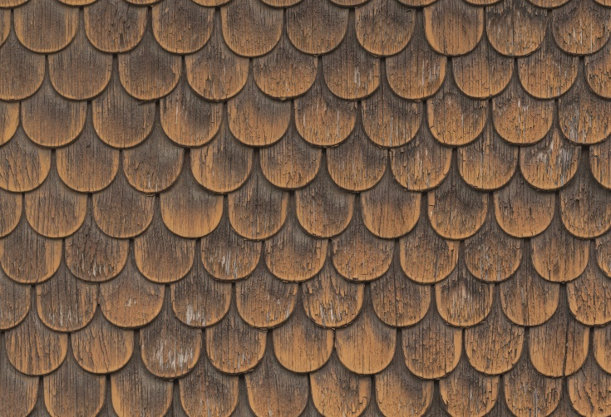

Activity_05 Old Character Wood

Draw character old wood from reference. Follow lecturer presentation and draw plank shape first, then wood texture values.

