Student Portfolio assessment

Business Unit/Work Group | THCA/Creative Industries
Qualification Code | CUA51015
Qualification Title | Diploma of Screen and Media (Game Art)
Unit Code/s | CUAACD502
Unit Title/s | Create observational drawings
Assessment Task Title | A_01 Sketchbook

Student Instructions
Instructions | - Read Task description  - Produce all required project evidence outlined in Project Instructions and Assessment Criteria section  - Complete all required supplementary evidence documents  - Summit electronically all project evidence listed in the table column 1 to specified server location  - Check that all project criteria in project evidence table column 2 addressed  - students will be advised on assessment outcome via students TAFE email within a week after submission due date  - Students have a right to one resubmission if the pass criterion for an assessment has not been met.  - Students have one week to resubmit the project  - You will have 4 weeks to complete assessment task A-01  - students work individually  - Your lecture can give you advice, however you must utilise all the knowledge, skills and resources gained during this course, and where necessary, access additional resources online Instructions and Assessment Criteria

Project Brief:
Complete set of practical activities to explore media and tools for observational drawings. Develop and refine observational drawing technique. Attend life drawings sessions, following class demonstrations and produce 3 observational drawings from provided set of objects with the focus on:
- Line Edge and Perspective
- Light and Shade
- Extreme Tone

Instructions and Assessment Criteria
- Attend class discussion “Introduction to Drawing” Research selected historical and contemporary observational drawing. Complete project research table below
 | a | b | c
Art Work | Artist (if known) and Historic Period | Medium and Techniques used | Summarise key aspects of the artwork that are relevant to your own practice
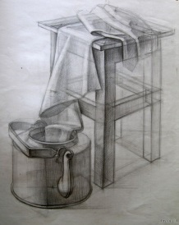
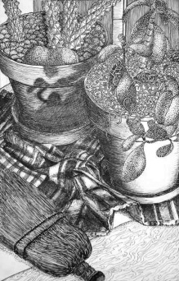
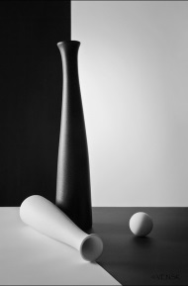

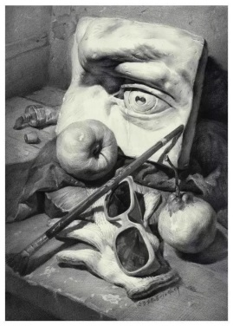

- Attend practical Activity “How to Hand Sharpen a Pencil” Describe 4 key considerations (a, b, c, d) to safely sharpen a pencil:
 | Key considerations | Describe how you do it safely
a | Safe position of the body in relation to the knife
b | Safe direction of the cut in relation to the body
c | Safe position of the thumb on the blade
d | How much pressure should be apply from your thumbs to the blade

- Attend life drawing class session “Line Edge and Perspective” complete still life drawing with the focus on the line edge and perspective. When finished scan or make a photo of your drawing and complete activity evaluation table below:
a | b | c | d
Insert photo of your completed drawing | How line and edges used in this drawing to achieve perspective, space and structure | What media, tools, technique selected to achieve the desired outcome? Why? | Compare your drawing with selected example(s), discuss with the lecture and peers, Identify two problems in own drawing technique and outline ways to resolve them
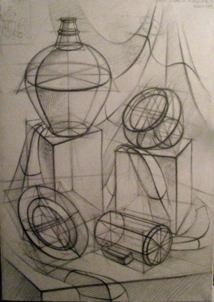 |  |  | 1  2
Insert Your drawing here
- Attend life drawing class session “Light and Shade” complete still life drawing with the focus on the rendering of subject form using light and shade. When finished scan or make a photo of your drawing and complete activity evaluation table below:
a | b | c | d
Insert photo of your completed drawing | How line, edges , tone and contrast used in this drawing to depict light, shade and represent space and perspective | What media, tools, technique selected to achieve the desired outcome? Why? | Compare your drawing with selected example(s), discuss with the lecture and peers, Identify two problems in own drawing technique and outline ways to resolve them
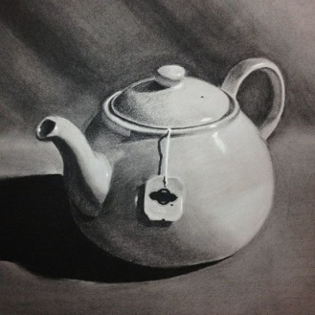 |  |  | 1  2
Insert Your drawing here

- Attend life drawing class session “Extreme Tone” complete still life drawing with the focus on the using extreme light and shade to depict positive and negative space. When finished scan or make a photo of your drawing and complete activity evaluation table below:
a | b | c | d
Insert photo of your completed drawing | How line, edge extreme tone and shape used in this artwork to represent space and perspective | What media, tools, technique selected to achieve the desired outcome. Why? | Compare your drawing with selected example(s), discuss with the lecture and peers, Identify two problems in own drawing technique and outline ways to resolve them
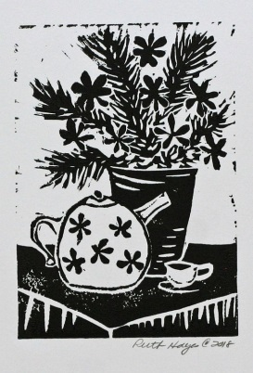 |  |  | 1  2
Insert Your drawing here

Submissions:
The following items should be submitted to the specified submission folders:
L:\GameArt\Submissions
- Completed A_01 Assessment Sketchbook document
- Folder with 3 photos or scans of completed observational drawings

Due date: week 6

Due date: week 9

Time allowed | 3 weeks
Location | Classroom and home
Recourses required | Learners are provided with; Computer station with internet access Learners must bring own drawing materials: graphite and charcoal pencils, A3 drawing sketchpad.
Decision making rules | To achieve a satisfactory outcome the student must satisfy all evidence requirements.

Evidence table
(Add more lines as required)

Instructions
- Number each evidence item and place the number in column 3
- Arrange your evidence items in a folder (electronic or paper-based as instructed). Include an index/hyperlinks so that evidence items can be located easily.
- In column 4 describe briefly why and how the item of evidence meets the quality requirement described in column 2.
- Only complete the last line in the table (Alternative evidence) if you are not able to provide a required item of evidence but have an equivalent item of evidence. If you do this state also what item of evidence is being substituted.

Evidence items required  (Assessor to complete) | Evidence should demonstrate/quality requirements  (Assessor to complete) | Evidence number  (Student to complete) | Comments/justification  (Student to complete) | S/NS  (Assessor  to complete)
- Folder with 3 photos or scans of completed observational drawings | - Minimum 0f 3 photos of completed drawings  - Drawings are comply with project brief requirements
- Completed A_01 Sketchbook document | - All instructions sections from 1 to 5 are completed

Assessor Comments
Review the evidence provided in the portfolio and identify any issues regarding the Rules of Evidence that will inform the questions in the table below.

