# Topic_01 Drawing Basic Shapes https://learn.tafesa.edu.au/course/view.php?id=2784#section-3

**Theory component: Answer the following questions**

1. What the difference between shape, form value and edge
2. Ask for lecturer feedback on different drawing techniques you used in actives 01- 03
3. In bullet point list how you can improve your drawing skills

## Class Discussion Drawing Basic Shapes

Watch video “The Basic Elements - Shape Value Color Edge”

<https://www.youtube.com/watch?v=TfAZt3O0sLY>

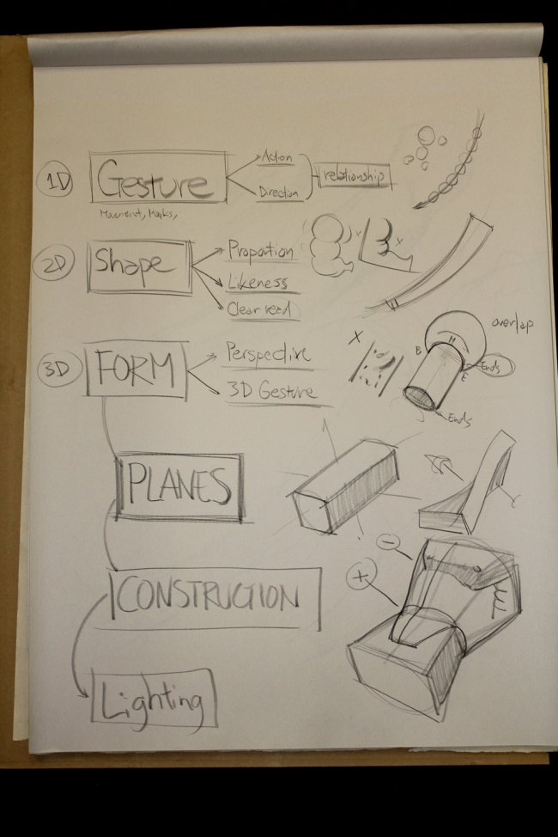 The "drawing basics" are the five main skills of drawing. They're the ability to: recognize edges, lines, and angles; to reckon proportion and perspective; deciphering shadow, highlights, and gradations of tone; and lastly, the ability to unconsciously drawstring them all together - which comes to you with practice.

## Activity _01: Shape vs Form and Value

Watch video “THE BASICS: Your three best friends-Cube, Sphere, Cylinder”

<https://www.youtube.com/watch?v=qpqEE9yU474>

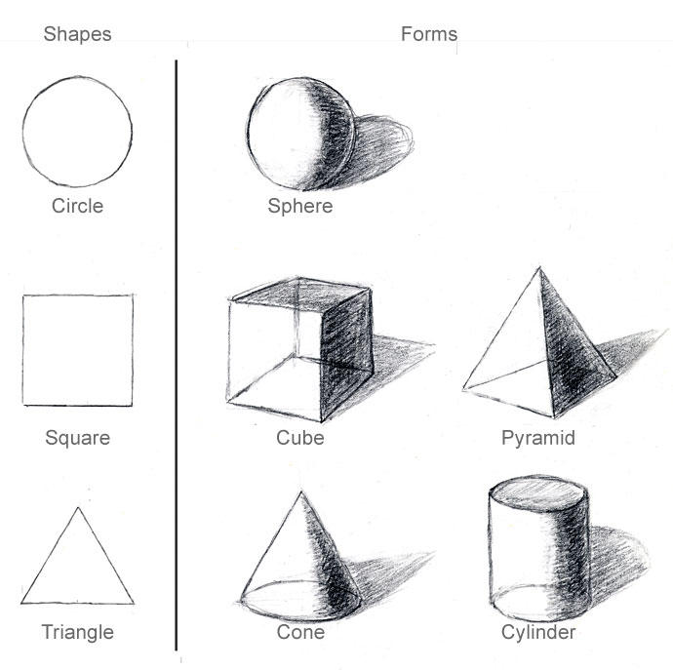This exercise is to help you understand these shapes and forms.  It will also have you begin to imagine how light affects three-dimensional objects and how cast shadows form from these objects.

Materials: 2B graphite pencil and drawing paper.

Start by drawing the three basic shapes, circle, triangle, and square all the same size, freehand, keep it loose,  Along side of the basic shapes, draw the 3D equivalents, a sphere, cone, and cube.

Pretend there is a single light source in the 10:00 o'clock position above them.

Imagine how the objects would be lit and where the shadow on the forms would be and how the cast shadow would fall and what the cast shadows shape would look like.

Next to the three-dimensional forms draw a variation of the cone, which would be a cylinder, and a variation next to the cube, a pyramid.  Now draw in the light and shadow sides of the forms, and the shadow that is casts form the form (Cast Shadow) from these objects. See sample drawing exercise below.

This exercise is designed to make you use only your minds-eye to create these objects and the lighting affect.

Activity_02 Proportions

Proportion is largely about the relationship of the size of one element when compared to another. When drawing realistically, proportion is important.

Draw the garden urn from the picture below, simplify the urn to the basic shapes and concentrate on of the size of the elements compared to another, Use grid to make task more manageable. 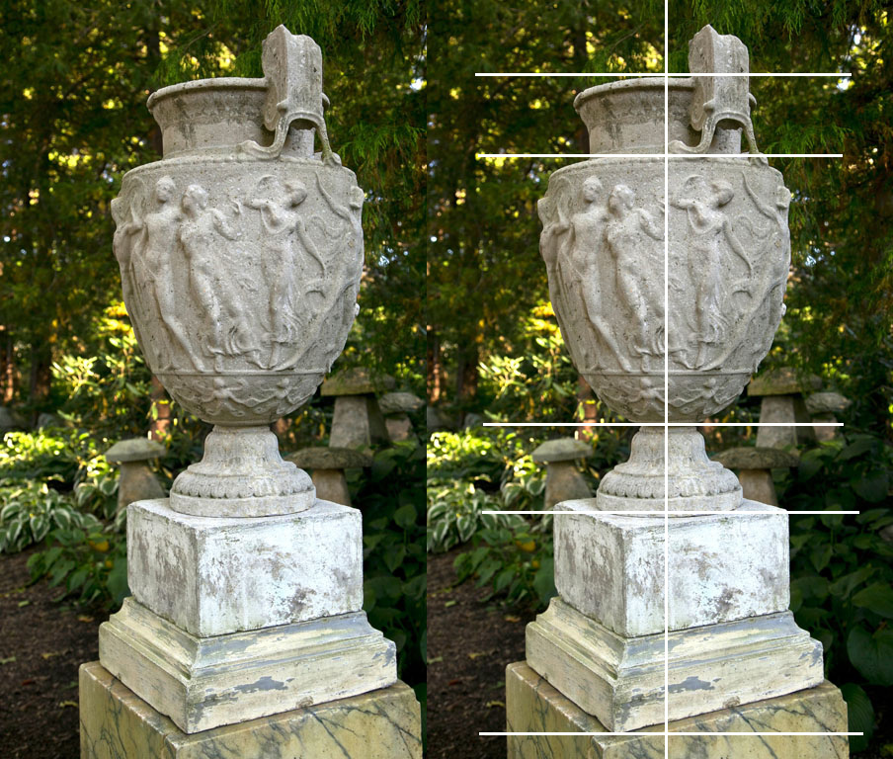

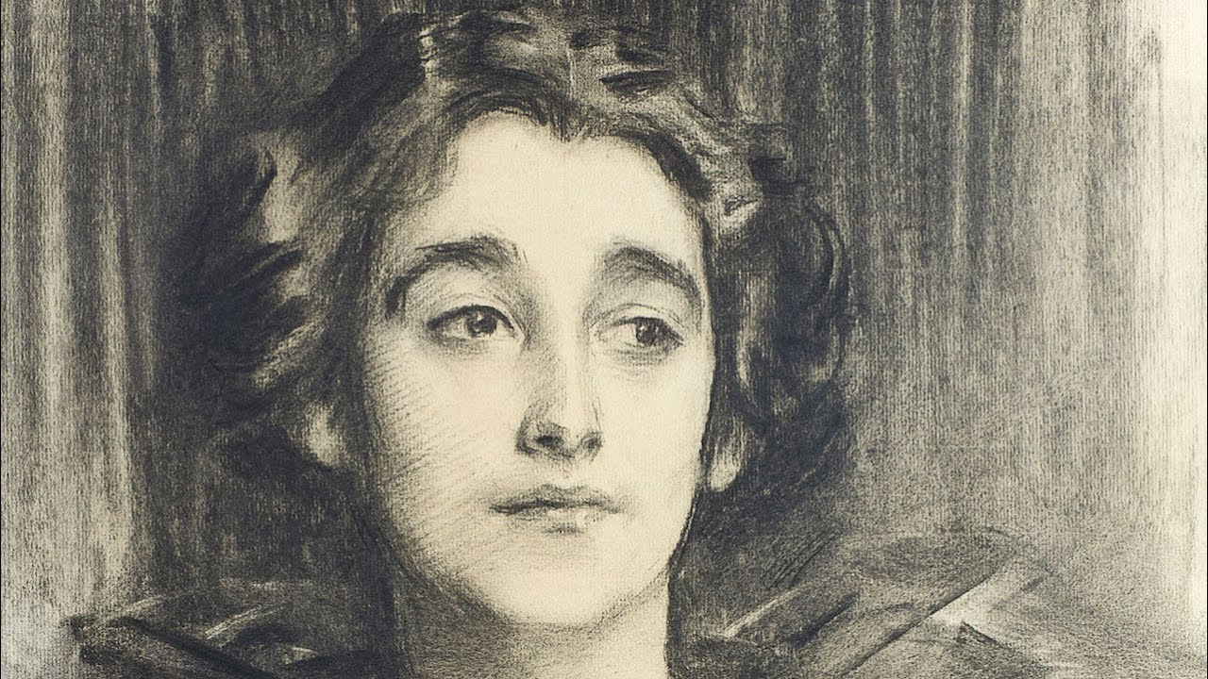Activity_03 Character and likeness

Legend has it that John Singer Sargent would tell people who complimented him on his drawing ability to capture a likeness of someone that likeness is more in the shape of the person's skull, the way a person "holds" his or her body, and the basic location of the features than in the details. That's why you can recognize someone far down the street. For Sargent, the placement of the eye sockets and the shape of the head are the crucial aspects in drawing people.

Draw two pottery vases from the picture below side by side, concentrate on the difference in the shapes of the vases:

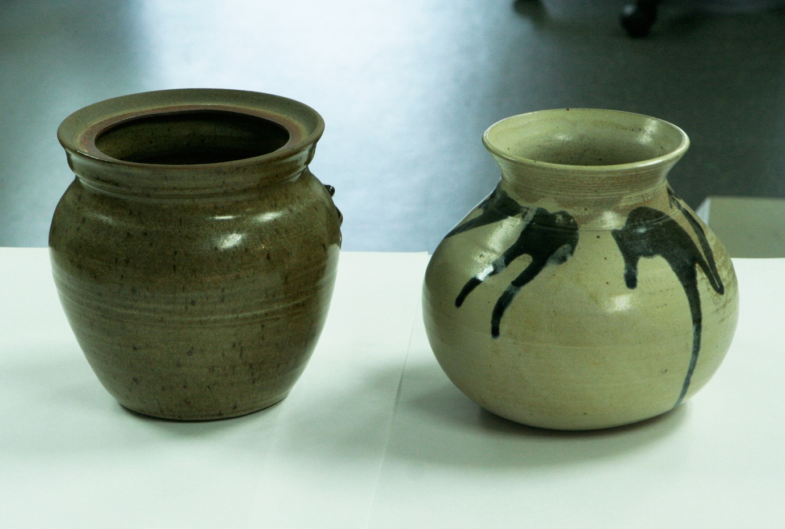

Activity_04 Drawing Composition (group of simple objects)  
let’s work a bit more on consolidating our familiarity with the four basic shapes: cones, spheres, boxes and cylinders.  Start by sketching the image below.

Don’t worry about making the shading the most important thing is to work on object shape, and composition keep it simple line drawing.

You can either draw the shapes using the grid, or without it. Keep you sketch small thumbnail size: maximum 10cm X 15cm

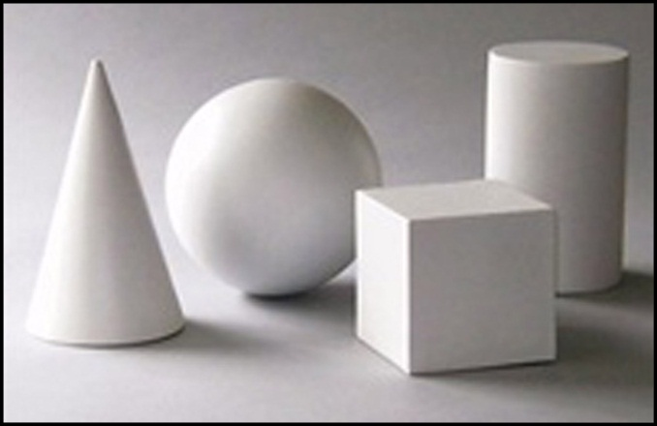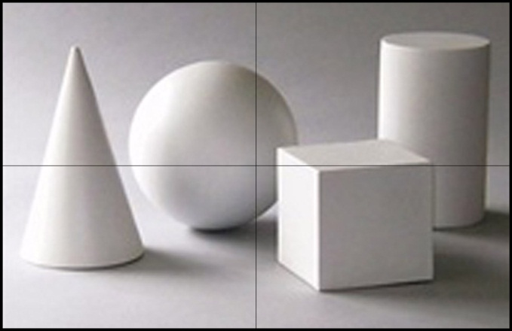

## Activity_05 Intuitive perspective

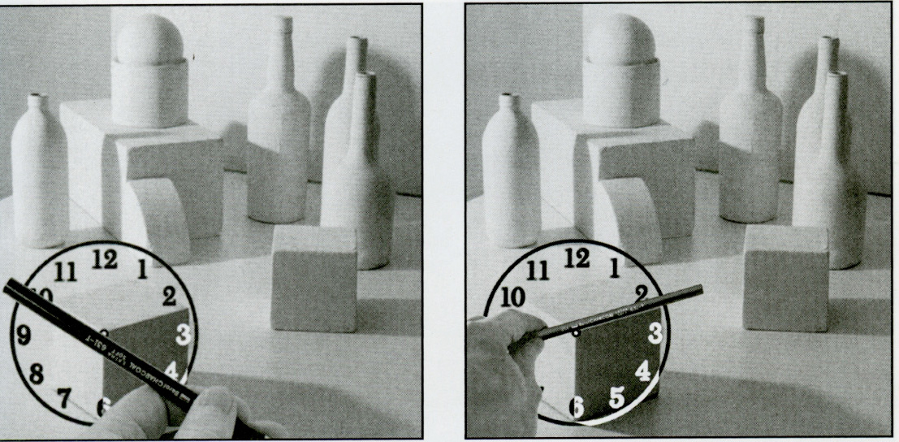

On this illustration student using “clock-angle” method to eyeball perspective of the cube.   
Try to draw this installation (photo below) notice that all objects in this still-life have different perspective angles, use intuitive perspective or clock-angle method to draw perspective correctly

Keep you sketch small thumbnail size: maximum 10cm X 15cm

**Draw still life (image below)**

Edge and shapes only, line drawing concentrate on composition and perspective

