# Topic\_02 How Shadows Work https://learn.tafesa.edu.au/course/view.php?id=2784#section-3

## In this topic learn how light affects the appearance of form and learn about the elements that make form look 3-dimensional: Light, shadow, highlight centre light, halftone, reflected light, form shadow, cast shadow, core shadow and occlusion shadow.

## Class Discussion Drawing Basic Shapes

1. Watch video “Shading Light and Form - Basics”

<https://www.youtube.com/watch?v=V3WmrWUEIJo&t=18s>

## Activity \_01 egg

Watch Proko video presentation “Shading Light and Form - Basics” and render black and white image of egg from the picture below:

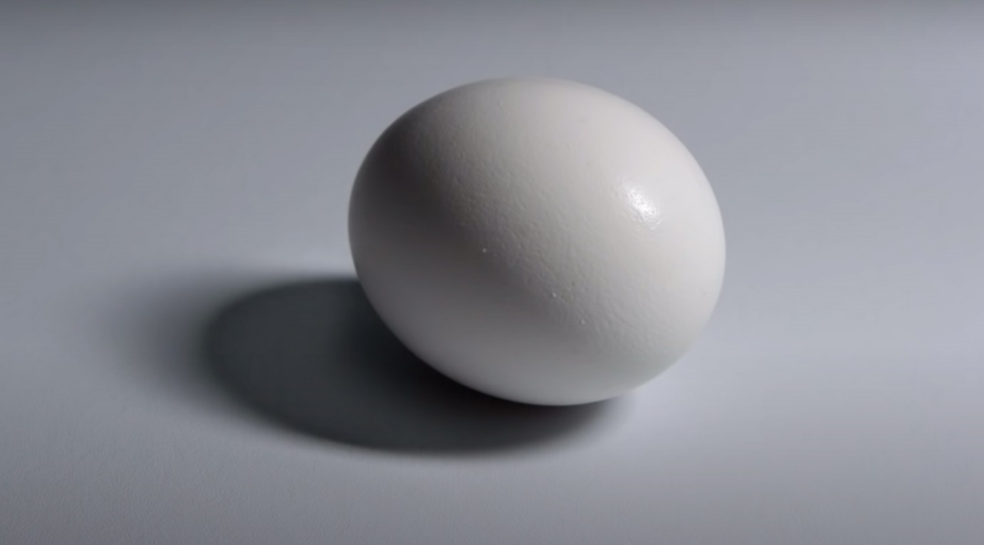

## Activity \_02: rendering billiard ball

## Pietro_Annigoni_1910_1988_italian_artist.jpg

1. Watch video “Mind-Blowing Realistic Shading Tricks”

Dorian Iten is a great artist and a master of shading light and form! In this video, he’ll reveal errors artists make when learning how to shade. You’ll learn important shading concepts like the angle of incidence, lambert's law, the issues with a linear value scale, and the difference between clean lights and dirty lights. At the end he’ll tie all of these concepts together with a brief shading demo and a drawing challenge. Enjoy!

<https://www.youtube.com/watch?v=6vapw6n6FyU>

Follow lecturer presentation and render black and white image of billiard ball from the picture below:

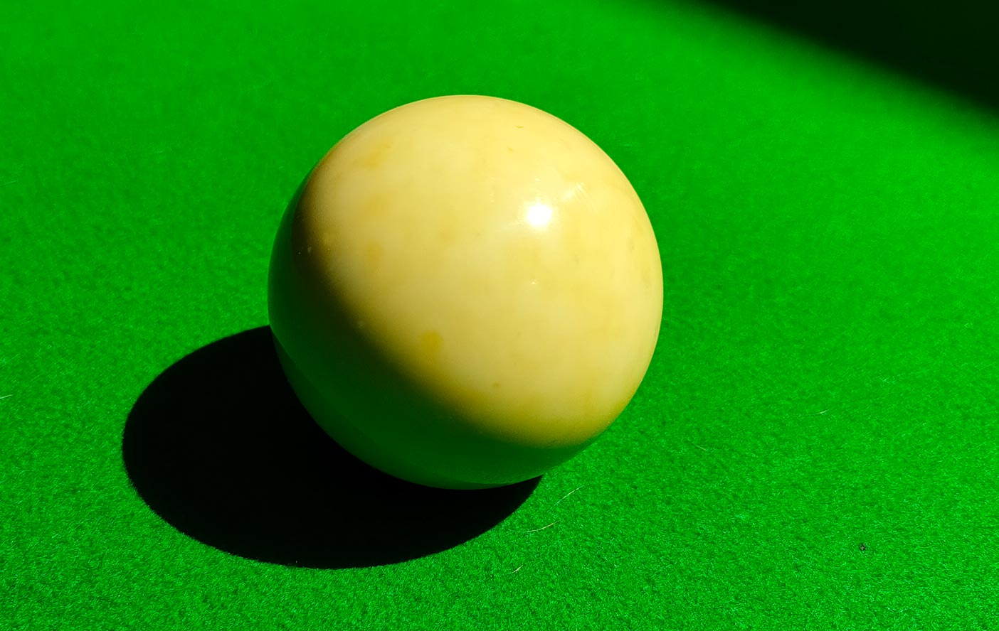

Activity\_03 Realistic Shading Tricks

copy this pencil stillife utilising knowledge of light and form from the video:

Activity\_04 more practise

Lets practise more shading and rendering use image below as a reference for developing shading and rendering techniques:

****

Activity\_05 Combine structure, proportions and shading

Use Still life picture below as a reference, draw the composition first, and then try to concentrate on light and shadows:

