# Topic 08 – Head

## The Human Head – basic shapes and proportions

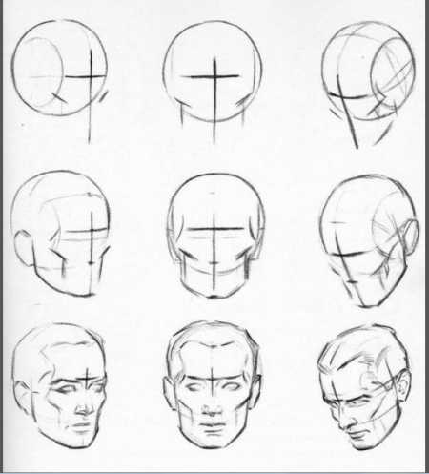We are summarizing Andrew Loomis's <http://en.wikipedia.org/wiki/Andrew_Loomis> approach to drawing the head. It's a great method for drawing the head from various angles. Draw the head from the front, side / profile, 3/4 view. Learn how to add an up or down tilt to the head, left and right turn, and a twist.

## Exercise 1: Draw the Head from Any Angle

<http://www.youtube.com/playlist?list=PL39135B8D190B7C97>

1. Watch the video <http://www.youtube.com/watch?v=1EPNYWeEf1U&list=PL39135B8D190B7C97&index=1>

­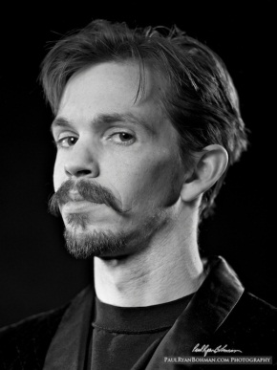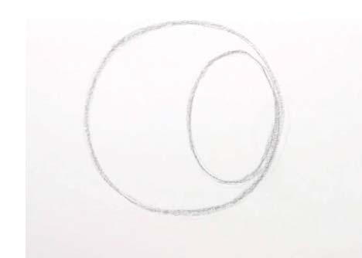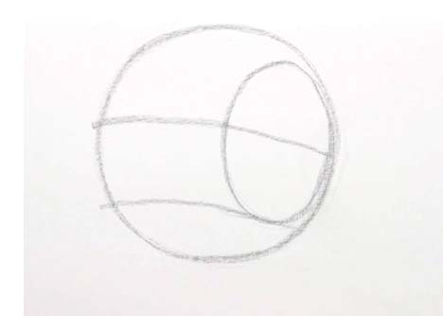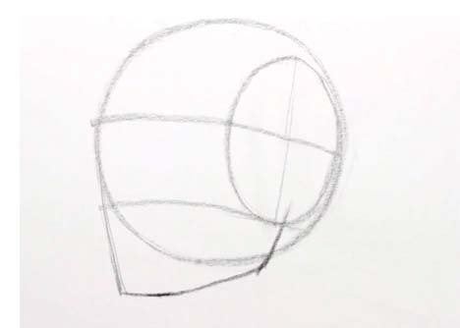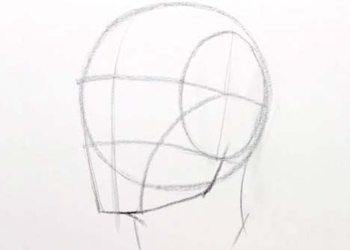

Draw from photograph act_001 and repeat these steps above:

# Exercise 2: How to Draw the Head - Front View

**Steps:**

1. Watch the video <http://www.youtube.com/watch?v=z4ZLkyTuX_w&list=PL39135B8D190B7C97&index=2>
2. Draw from photograph act_002 and repeat steps explained in video tutorial:

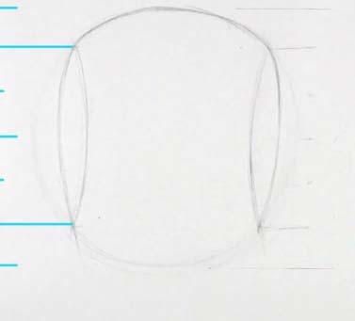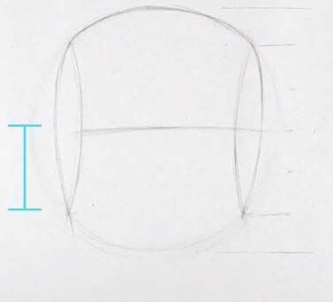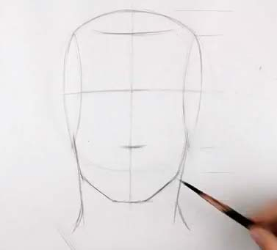

# Exercise 3: How to Draw the Head - Side View

**Steps:**

1. Watch the video <http://www.youtube.com/watch?v=yS6R2l8t8wo&list=PL39135B8D190B7C97&index=3>
2. Draw from photograph act_003 and repeat steps explained in video tutorial

# Activity 4: How to Draw the Head from Extreme Angles

**Steps:**

1. Watch the video <http://www.youtube.com/watch?v=PgK90TpV5fA&list=PL39135B8D190B7C97&index=4>
2. Watch David Finch dynamic figure drawing head  
   <https://www.youtube.com/watch?v=tD9NFW8rEwo>
3. Draw from photograph act_004_a simplify head into a box first
4. repeat steps explained in video tutorial:
5. Repeat the drawing steps using photograph act_004_b

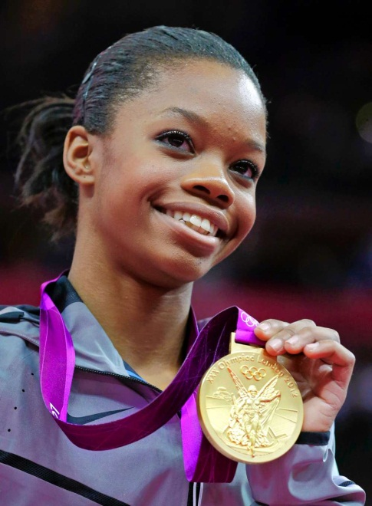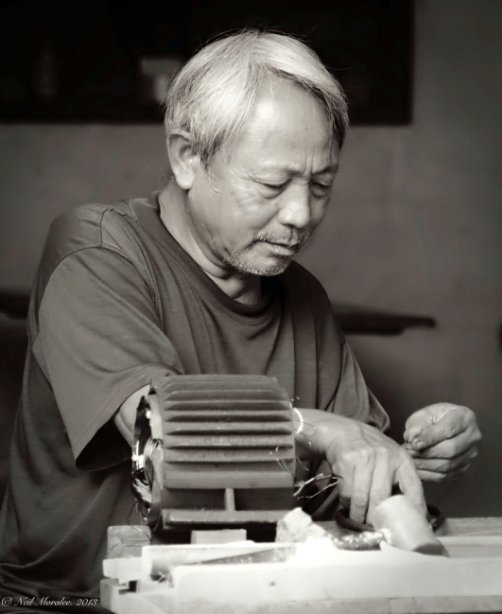

# Homework

Draw self-portrait from the mirror

Draw the basic construction lines that you have learned

#### Resources:

YouTube Channel - [**https://www.youtube.com/user/ProkoTV**](https://www.youtube.com/user/ProkoTV)

Website: <http://www.proko.com/human-figure-proportions-cranium-unit-hale/>

Personal Website - [**http://www.stanprokopenko.com**](http://www.stanprokopenko.com/)