Design rules to create good game prop:

Prop must have function and utility
function is what something does or is used for while utility is the state or condition of being useful, usefulness.

Prop design concept combines the best elements from host of other existing designs:

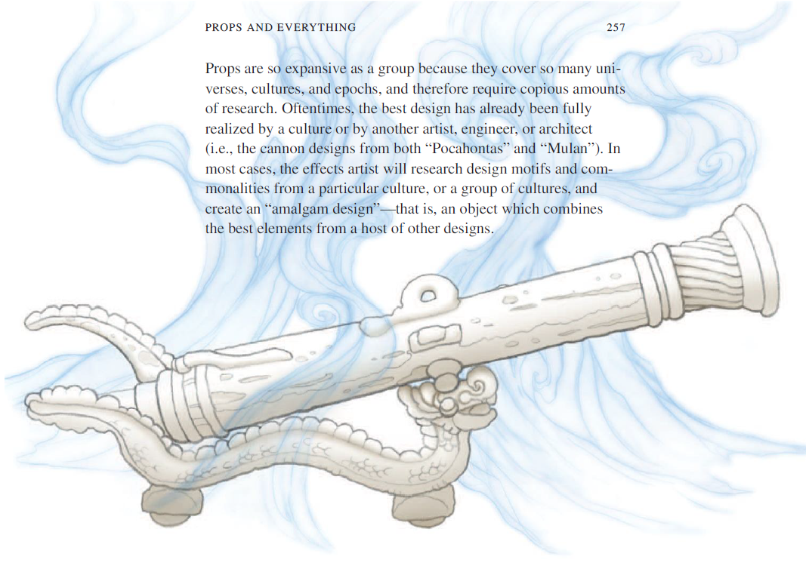

Design rules to create game prop that enhance player experience:
1. Suggestion of Substance
the prop should have the illusion of weight that is suggested by the exaggerated shape, details and textures that represent real materials.
2. Suggestion of material and function
Make metal look like metal; use screws or rivets to show how it is supposedly assembled. Use hinges to show if a lid can be opened. It should suppress the disbelief that is does not or cannot function.

3. Suggestion of Functionality suppressing disbelief
If your intent to present a technology that has no real or existing counterpart, try to suggest a ‘narrative logic’ to the technology in its visual form.
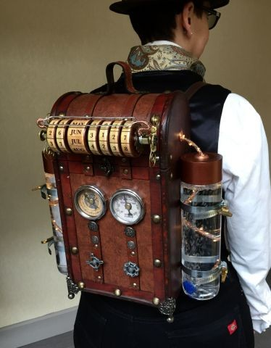
The example ‘backpack’ pretends to facilitate ‘time travel’ and the visual elements (like the scroll-like interface) suggests this function (you can ‘enter’ date and year of your destination) while being mysterious in how it exactly would work.

4. Suggestion of History
games suggest history, weathering is quintessential to suggest age and heritage. Go as far as creating a narrative in your head of the life span of the object while using textures to ageing the prop to come up with convincing wear and tear. Use design elements to facilitate your story. Viking sward with Keltic ornaments, wear and battle damage is more interesting and desirable than generic blade.

5. Suggestion of Personification of ownership
Another interesting way of adding value, which is an extension of rule 4, is personifying the prop relating it to a famous person or historical period or event. A vintage guitar is one thing, but the same vintage guitar ‘played by Paul McCarthy in 1967’ multiplies its value by a tremendous amount.

6. Suggestion of Magic
In your design include elements that mimic objects that have an existing track record of being ‘magical’; gems, dream catchers, wands, occult sand timers, bird skeletons ...
Enter the realm of the ‘amulet’, the object with a soul.

Bibliography:
- Seven design rules to create good game props. Published on January 21, 2020
https://www.linkedin.com/pulse/seven-design-rules-create-good-game-props-willem-jan-renger

- Elemental Magic Volume I: The Art Of Special Effects Animation by J Gilland · 2012.

