**Kuku Yalanji woman Pat O’Shane: ‘I’m fired up about education, injustice and sovereignty’**

[**Alex Bainbridge**](https://www.greenleft.org.au/glw-authors/alex-bainbridge)

[**Pat O'Shane**](https://www.greenleft.org.au/glw-authors/pat-oshane)

[Cairns](https://www.greenleft.org.au/location/cairns)

January 28, 2022

Issue

[1331](https://www.greenleft.org.au/glw-issues/1331)

[Australia](https://www.greenleft.org.au/country/australia)

[Facebook](https://www.greenleft.org.au/#facebook)[WhatsApp](https://www.greenleft.org.au/#whatsapp)[Messenger](https://www.greenleft.org.au/#facebook_messenger)[Telegram](https://www.greenleft.org.au/#telegram)[Twitter](https://www.greenleft.org.au/#twitter)[Reddit](https://www.greenleft.org.au/#reddit)[Email](https://www.greenleft.org.au/#email)[Print](https://www.greenleft.org.au/content/kuku-yalanji-woman-pat-oshane-im-fired-about-education-injustice-and-sovereignty#print)

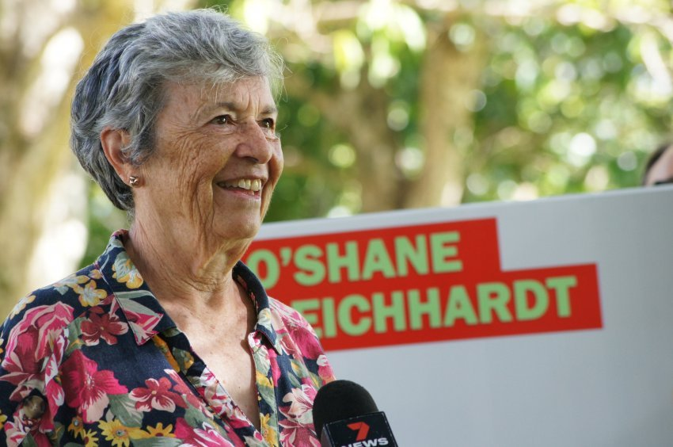

Kuku Yalanji woman Pat O’Shane.

Distinguished Kuku Yalanji woman [**Pat O’Shane**](https://socialist-alliance.org/elections/federal/2022/election-candidate/pat-oshane) is running for Socialist Alliance in the seat of Leichhardt. O’Shane is a retired barrister and a former New South Wales magistrate. O’Shane spoke to *Green Left*’s **Alex Bainbridge**about what fires her up and why she decided to contest this important election.

**You were awarded the NAIDOC Lifetime Achievement Award for your longstanding advocacy last year. You have also come in for a fair bit of criticism. Can you share some highlights from your distinguished career?**

**See also**

[Pat O'Shane: I’m fired up about injustice](https://www.greenleft.org.au/content/pat-oshane-im-fired-about-injustice)

[Pat O’Shane to stand in Leichhardt for the Socialist Alliance](https://www.greenleft.org.au/content/pat-oshane-stand-leichhardt-socialist-alliance)

I’m driven by a sense of equity and justice: that is why I went into the law. All my life, the treatment of Aborigines has been horrendous. People were and still are getting killed.

I started as a young teacher of Indigenous classes at Cairns Central Primary School and later at Cairns State High School. The kids had very poor levels of understanding. We didn’t have a library and the kids didn’t have books at home. They lived in desperate poverty, so I bought books for my class. Our library was a wooden stool in the classroom and the books were Little Golden books about animals, trees and insects. The kids took to them. I also used to take them out into the school yard one day a week, to grow gardens. On one side they grew flowers and on the other they grew veggies. They became very involved in gardening.

This is where you start: from where they are and you give them something new to explore. I wasn’t taught that in my schooling, teacher training or in my university studies. It just seemed to be the most intelligent and sensible thing to do. One afternoon a week I would take the kids down to the Cairns Esplanade where, when the tide went out, the water still trickled down through the mud. They could see the creeks and the islands and they could look over the bay to see where they lived. Their geography classes were done looking at those features; they learnt by seeing.

I taught high school history and the recommended book for grade 9 said Aborigines were “primitive” people because they couldn’t turn wheat into flour. I threw the book out the window and I got the kids to write their own history. I told them to talk to their mums and dads, aunties and uncles, grandparents and neighbours. I told them to write about where they come from and who their people are. For the first time in their lives, they were enthusiastic about their homework because it meant something to them.

It still aggravates me that people will say there’s no point in trying to educate Blacks because they can’t learn. Nothing much has changed under Prime Minister Scott Morrison and his cohort. They don’t put money into education for Indigenous people or for those in the community who are depressed or lack education or jobs or income.

**Your family was involved in the communist movement. Can you elaborate?**

I’ve a long-term connection to the Far North. My family are here, and my entire First Nations family have lived here for many generations. We’re the Traditional Owners of the Daintree rainforest, the world’s oldest lowland tropical forest.

My mother joined the Communist Party of Australia (CPA) when I was young. I didn’t join until much later when I went to Brisbane, but then I dropped out again. My father, a wharfie, never joined, but he always supported mum. Mum got into the CPA through the union-women’s supporter group where she met other women of like mind. She started attending conferences down south and became very active in the anti-war movement, the movement to stop nuclear bomb testing in the Pacific and the Aboriginal rights movement.

My mother was a very powerful presence in these movements. Even as a high school kid, the movements appealed to me on an intellectual level. It had always been impressed on me by my parents and grandparents that I should treasure the opportunity to get a good education and do as well as I could. I thought my role in life was to do well in school (in spite of teachers who told me “Blacks can’t learn” with one even accusing me of cheating which I never did!).

I joined the anti-war movement when I went to Sydney. I never joined the Labor Party; I wasn’t impressed by it then, nor am I impressed now. It seems to be insufficiently committed — although it does have some are honourable politicians, unionists and activists.

**Why did you decide to contest Leichhardt?**

Well, who else would I run with? Cairns councillor Rob Pyne contacted me, suggesting I consider standing for Socialist Alliance and I said “Yes” straight away. He invited me to his workplace at the council for a chat. The ethics and principles of Socialist Alliance align with my purposes.

**What’s your approach to justice for First Nations people?**

First, I would deal with the poverty levels by providing social housing on their own land. Then I would ensure there was good education. I’d get rid of the churches and ensure they had access to good jobs.

The Aboriginal Land Rights Act, imagined by white lawyers, doesn’t come up to the mark. It consists of an intricate web of legal principles. Most people — including lawyers — don’t even understand it. I knew the lawyers who worked on the Native Title legislation and why they agreed to write the principle of terra nullius into it is beyond my understanding. It was a total sell-out, an absolute travesty even in legal terms.

If elected, I’ll be pushing that issue very hard. I won’t agree to laws that do not protect sacred places allowing mining giants to blow them up to make money — as has happened in Western Australia. World heritage sites should have absolute protection.

**What’s your approach to climate change?**

We should leave the coal in the ground and we need to replant the trees. We have to ensure we reduce the carbon emissions that are destroying our environment. We need a government that will put more pressure on mining companies.

As a species, we cannot afford for them to keep polluting the land and the air. What is worse is that other species that cannot fight for their existence, cannot afford it. We have to fight for every species on Earth, and to do that we have to get rid of governments like Morrison and his mates.

**What’s your attitude to a possible federal Labor government?**

I’ve been watching Labor leader Anthony Albanese for a long time and he doesn’t stir my sense of rage about the injustice in this country. I might be doing him an injustice, but I cannot remember him getting on the bandwagon for Aboriginal land rights and justice. I know some Labor people do, and I’ve gone on protests with them, but they aren’t the leaders.

If elected, I would resist any invitation from Labor to join. If they raise issues I consider worthy, I would support them. If not, I will make it known why. I have very strong feelings about injustice and I am not interested in being like Warren Entsch, who has been polishing the seat for a long time while not advancing the community.

**What is Warren Entsch’s record and what would you do if elected?**

Entsch has been the Liberal National Party of Queensland MP here for many years. Shortly after I came back to Cairns, United Nations representatives wanted to see the impact of climate change on the Great Barrier Reef. Entsch is apparently the Australian envoy for the Great Barrier Reef so I looked through his Parliament House speeches, voting records and statements and discovered he has done nothing.

He made one comment about the reef “doing well” and that its bleaching hadn’t been caused by climate change. He doesn’t believe in climate change even if he’s made a couple of weasel-like comments about it.

I have watched and listened and concluded he has done nothing for North Queensland. He has never voted to change any bad practices in parliament. Indeed, his voting patterns say to me that he will vote how he is told to. That translates as getting paid big money to do absolutely nothing. He promotes himself around Cairns as someone who is “stable” and “can be trusted”. But he’s none of those things.

[To help Pat O’Shane’s campaign for Leichhardt [get in touch](https://socialist-alliance.org/elections/federal/2022/election-candidate/pat-oshane) with Jonathan Strauss on 0437 790 306.]