APPRAISAL - Text evaluation

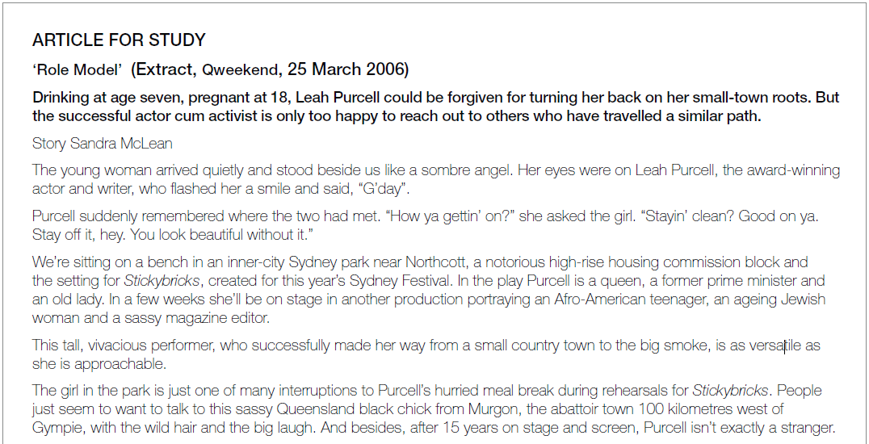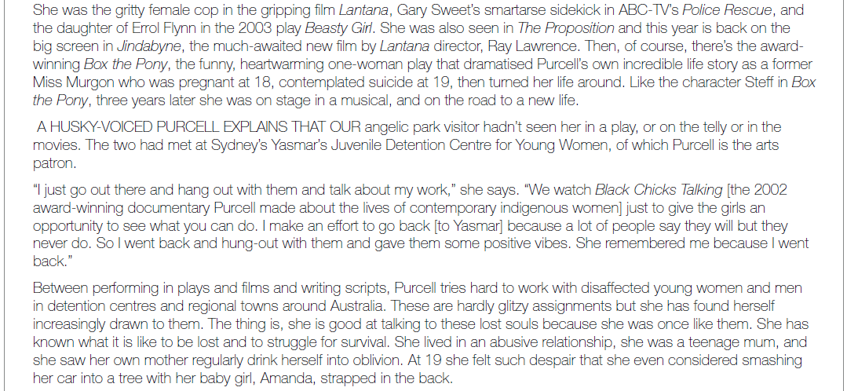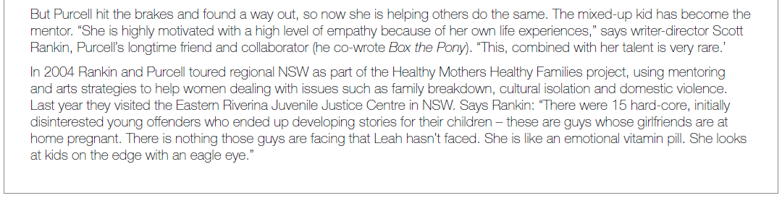



McGuire R, 2008, ‘Grammar at the chalkface: an introduction to the grammar of Appraisal and its application in a Year 9 classroom’ *mETApho*r, Issue 1, 2008 p 48

JUDGMENT:

Resources for expressing positive or negative judgements directly or implicitly about a person’s behaviour. At one level in terms of social esteem we may assess behaviour as socially acceptable (praiseworthy) or unacceptable (deplorable). At another we may assess it more seriously, in terms of social sanction (as moral or immoral, just or unjust).

|  |
| --- |
| What kinds of JUDGMENTS (eg personal or moral) are made directly or implicitly about a person’s behaviour?  LOOK FOR positive and negative JUDGMENTS expressed by, eg:   * verbs eg *to cheat; to lie; to deceive; to chicken out* * adverbs eg *justly, fairly, virtuously, honestly, cleverly* * adjectives eg *virtuous v immoral; honest versus deceitful; brave v cowardly;* and * attributes eg *That was dishonest; Don’t be cruel; She’s very brave* * nouns eg *a brutal tyrant; a cheat and a liar; a hero* * words located on a sliding scale eg *an ok player, a skilled player, a brilliant player.*   JUDGMENTS can be explicit (‘The government is incompetent’) or implicit (‘The government has not laid the foundations for economic growth’). |

Judgment: Leah Purcell

The following framework represents the way Leah Purcell has been constructed in the profile.

**Fill in the table:**

|  |  |  |
| --- | --- | --- |
| **Social Esteem** | **positive (admire)** | **negative (criticise)** |
| normality ( custom)  ‘Is the person’s behaviour unusual, special, customary? |  |  |
| capacity  Is the person competent, capable? |  |  |
| tenacity (resolve)  Is the person dependable, well disposed? |  |  |
| **Social Sanction** | **positive (praise)** | **negative (condemn)** |
| veracity (truth)  Is the person honest? |  |  |
| propriety (ethics)  Is the person ethical, beyond reproach? |  |  |

FROM Iedema et al, 1994

McGuire, p 50

Judgment: Leah Purcell

The following framework represents the way Leah Purcell has been constructed in the profile.

|  |  |  |
| --- | --- | --- |
| **Social Esteem** | **positive (admire)** | **negative (criticise)** |
| normality ( custom)  ‘Is the person’s behaviour unusual, special, customary? | *Approachable*  *Sombre angel*  *Eagle eyed* | *Mixed up kid* |
| capacity  Is the person competent, capable? | *versatile; vivacious performer; talented; successful actor* |  |
| tenacity (resolve)  Is the person dependable, well disposed? | *turned her life around (courageous); hard-working (*dependable; persevering*)* |  |
| **Social Sanction** | **positive (praise)** | **negative (condemn)** |
| veracity (truth)  Is the person honest? | *(genuine, frank)* |  |
| propriety (ethics)  Is the person ethical, beyond reproach? | *arts patron (Yasmar Detention Centre); mentor; highly motivated; empathetic; emotional; emotional vitamin pill; (*caring, sensitive, considerate, resolute) |  |

FROM Iedema et al, 1994

McGuire, p 50